H.T No
Regulations:
A17

Sreenidhi Institute of Science and Technology
(An Autonomous Institution)
Code No: 6H315 Date: 19-Dec-2022 (FN)

B.Tech II-Year I- Semester (A18) Special Supplementary Examination - December-2022
Engineering Mathematics-III (Common to All)
(Numerical Methods, Complex Analysis & Special functions)

Time: 3 Hours Max.Marks:75

Note: a) No additional answer sheets will be provided.
b) All sub-parts of a question must be answered at one place only, otherwise it will not be valued.
c) Missing data can be assumed suitably.

ANSWER ANY 5 OUT OF 8 QUESTIONS. EACH QUESTION CARRIES 15 MARKS.

Bloom's Cognitive Levels of Learning (BCLL)

Remember | L1 | Apply | L3 | Evaluate | L5
Understand | L2 | Analyze | L4 | Create | L6

 |  |  | BCLL | CO(s) | Marks
1. | a) | Using method of Bisection, find the real root of 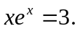 | L5 | CO1 | [8M]
 | b) | Evaluate 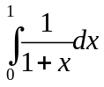 using Simpson’s 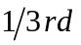 and 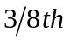 rule. | L5 | CO1 | [7M]
2. | a) | Apply Gauss-forward central difference formula and estimate f(32) from the following table | L3 | CO2 | [8M]
  x | 25 | 30 | 35 | 40
  f(x) | 0.2707 | 0.3027 | 0.3386 | 0.3794
 | b) | Find the interpolating polynomial f(x) from the table | L5 | CO2 | [7M]
  x | 0 | 1 | 4 | 5
  y | 4 | 3 | 24 | 39
3. | a) | Apply 4th order Runge- Kutta method to find 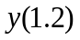 in steps of 0.1 for the differential equation 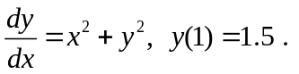 | L3 | CO3 | [10M]
 | b) | Explain the Euler’s method to find solution of an ordinary differential equation. | L2 | CO3 | [5M]
4. | a) | Express J₅(x) interms of J₀(x) and J₁(x). | L3 | CO4 | [8M]
 | b) | Evaluate 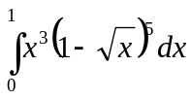 | L5 | CO4 | [7M]
5. | a) | Discuss the analyticity of the function 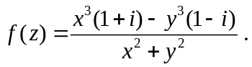 | L3 | CO5 | [8M]
 | b) | Find the Laurent series expansion of the function 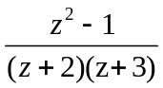 if 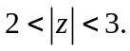 | L5 | CO5 | [7M]
6. | a) | Find the image of the intimate stamp 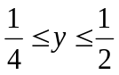under the transformation w=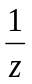. | L5 | CO6 | [8M]
 | b) | Find the bilinear transformation which maps the points (-1,0,1) into the points (1,i,3i) | L5 | CO6 | [7M]
7. | a) | Find real root of 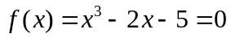 using Newton-Raphson method. | L5 | CO1 | [8M]
 | b) | Using Euler’s method of successive approximation, find 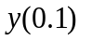and 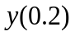 for  the differential equation 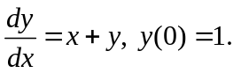 | L3 | CO2 | [7M]
8. | a) | Evaluate 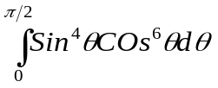 | L5 | CO4 | [8M]
 | b) | Evaluate s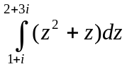along the line joining the points(1,1) and (2,3). | L5 | CO5 | [7M]

-- 00 -- 00 –

